8. März Internationaler Frauentag * 8. Mart Dünya Emekçi Kadınlar Günü * 8'é Adar'é roja jinén cihané * 8th March International Women's Day *
8. marzo La Giornata internazionale della donna (italienisch) ....

- The demand for income equality is as old as the women's movement itself. In 2014, women working full-time in Austria still earn 22.7% less than their male counterparts – despite the fact that women have caught up and even surpassed men in educational achievement. Austria comes second to last EU-wide with regard to the "gender pay gap" - the difference in income earnings between genders!

- In recent decades, women's employment in Austria has steadily increased. At the same time, the part-time employment rate for women is nearly 45% compared to 9.0% for men. In 2012, around 81% of part-time workers were female.

- Part-time and atypical employment also lead to poverty in old age for women. In Tyrol, men receive a pension averaging 47.2% more than women.

- The slogan of so-called "integration through performance" contains an irredeemable promise to "migrants"! It has been evidenced that women who do not have "typically Austrian-sounding names" have to apply for jobs more often than others before they are successful on the Austrian employment market. According to a survey by the Austrian Chamber of Labour, "migrants" work around 30% below their level of qualification and earn significantly less than their "Austrian" counterparts. Through racism and sexism, female migrants are subjected to multiple discrimination.

- Only 2.7% of men in Tyrol take parental leave and receive childcare allowance.

- The family environment is demonstrably the most dangerous place for women and children. In Austria, 30 to 40 women are murdered by their (ex-)partners annually.

- According to a large-scale study in the EU, 1 in 3 women has already suffered physical and/or sexual and/or psychological violence.

- Between 1 in 2 or 1 in 3 disabled women has experienced violence. Women with disabilities are doubly disadvantaged - as women and as individuals with a disability: Social discrimination experienced as a woman merges with the institutionalised dependence on caregivers and care systems.

- In Austria, not even 1 in 10 rapes is reported. And less than 1 in 5 prosecutions end in a conviction.

- More women (51%) than men live in Tyrol. Due to institutionalised discrimination, however, they are not involved in political decisions to the same degree. The proportion of women in the Tyrolean Landtag is only 30.6%, an even leaner 16.4% in the municipal councils and only 11 of 279 mayors in Tyrol are women. This corresponds to 3.9%! With regard to the distribution of power, Austria is far behind the EU average, ranking 23rd among the 27 EU Member States.

- ...

Imprint:
Frauenvernetzungsgruppe für Begegnung und Austausch, c/o Arbeitskreis Emanzipation und Partnerschaft – AEP, Schöpfstraße 19, Innsbruck. An der Frauenvernetzungsgruppe beteiligte Organisationen, Initiativen, Vereine:
Agru Zora, Aktion kritischer Schüler_innen - AKS, Alevitische Gemeinde Innsbruck (Innsbruck Alevi Kültür Derneği), Amara - Kurdische Frauen (Kürt Halk Evi - Kurdisches Volkshaus), bidok: Behinderung - Inklusion - Dokumentation, Büro für Gleichstellung und Gender Studies Universität Innsbruck, Demokratische Frauenplattform, Dersim Kultur- und Naturschutzverein, Die neue Frau (Yeni Kadın), Europäische Demokratische Frauenbewegung - ADKH (Avrupa Demokratik Kadın Hareketi), FiMMiT - Fraueninitiative von Migrantinnen und Musliminnen in Telfs, FrauenLesbenVernetzung Tirol – FLV (AEP-Frauenbibliothek, Aranea, ArchFem, Autonomes FrauenLesbenZentrum, Dowas für Frauen, Frauenreferat der Diözese, Frauen aus allen Ländern, Frauen im Brennpunkt, Frauen gegen Vergewaltigung, Gleichbehandlungsanwaltschaft - Regionalbüro für die Gleichbehandlung von Frauen und Männern in der Arbeitswelt für Tirol, Salzburg und Vorarlberg, iBUS - Innsbrucker Beratung und Unterstützung für Sexarbeiterinnen, Kinovi[sie]on, Verein Netzwerk Geschlechterforschung, Netzwerk österreichischer Frauen- und Mädchenberatungsstellen, Tiroler Frauenhaus), Grüne Frauen Tirol, Initiative Minderheiten, Integration Tirol, ÖGB-Frauen Region Innsbruck und Umgebung, Plattform Bleiberecht, SPÖ-Frauen Tirol, Tiroler Gesellschaft für rassismuskritische Arbeit - TIGRA, Verein LILITH, Weltgebetstag der Frauen.
Female voices
"As women, we demand:
- an end to the pay gap
- a minimum wage of 1,500 euros.
- a duty for companies of all sizes to disclose income reports.
- full-time employment for self-determined living."
(ÖGB-Frauen Region Innsbruck und Umgebung)
"Another world is possible. Women's freedom lies in their own hands. Fight against the patriarchal system!"
(Die Neue Frau - Yeni Kadin)

"Being women, being free, being successful – we will not be disabled"
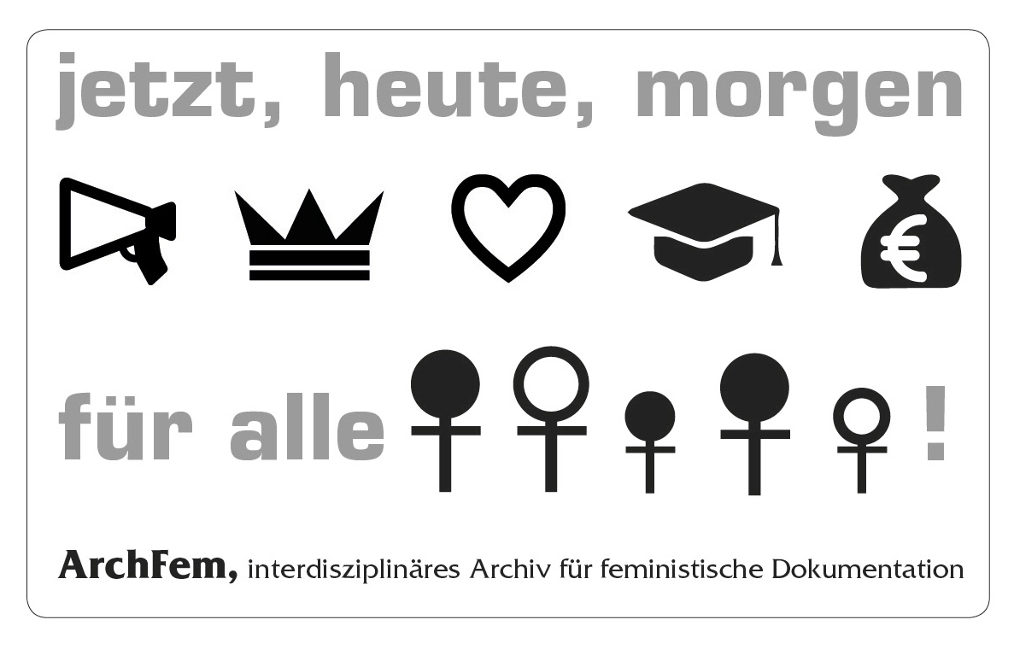
"Violence against women is a human rights violation and a criminal offence" (Verein LILITH)

"THE woman does not exist. Therefore, various social and economic positions, different realities and life concepts must always be considered when calling for equality. Why is the right of residence linked to proficiency in German or marriage? Why is not everyone living in Austria entitled to vote or work? We are not all the same - but we demand the same rights for everyone!" (Frauen aus allen Ländern)

"LESBIANS ARE ... saleswomen, grandmothers, MEPs, taxi drivers, postal carriers, unemployed, teachers, aunts, social workers, lovers, waitresses, nurses, athletes, doctors, farmers, mothers, immigrants, car mechanics, women with disabilities, bus drivers, volunteers, police officers, girlfriends, Catholics, Muslims, Jews, work colleagues ... RESPECT INSTEAD OF DISCRIMINATION! (Autonomes FrauenLesbenZentrum)

"We are committed to raising awareness for the situation of women in the Middle East and their struggles for peace and democracy. We demand an end to the long-standing war in Kurdistan on the basis of democratising the Middle East, the recognition of the peoples' right to self-determination and of equality between men and women. Our main focus is on combating and preventing all forms of violence against women. In solidarity with all oppressed women, for an honest egalitarian society which imposes no roles and behaviour on women." (AMARA – Frauenkomitee Kurdisches Volkshaus)

"FiMMiT is the first women's initiative by migrant women and Muslims in Telfs. Eliminating prejudice and discrimination, promoting cross-cultural dialogue, participation and integration are some of our goals. Over 15,000 people live in Telfs. 2,559 of them have a foreign nationality. Join us and be part of our multicultural women's initiative!" (FiMMit)
No to violence against women!
Equal pay for equal work!
No to gender injustice!
(Alevitische Gemeinde Innsbruck)

"We wish to build a bridge and promote communication between gender researchers on the one hand and state and civil society activists and organisations working for gender equality on the other." (Verein Netzwerk Geschlechterforschung)
"Our work is aimed at achieving self-determination and equal standing for women within society and within the party. With joy and relish, we pursue courageous women's politics!" (Die Grünen Frauen Tirols)
"Austria introduced an abortion time limit in 1975. In 2015, it is however still not possible to have an abortion in a public hospital in Tyrol. The SPÖ-Frauen Tirol continues both to fight for every woman's right to self-determination and to campaign for prevention, education as well as uncomplicated and inexpensive access to contraception." (SPÖ-Frauen Tirol)

